Civil war in Somalia

UNSC Resolution: | 794
Date of adoption: | 3-Dec-1992
Operative paragraph: | 2
Demand number: | 794,0211

Sarah-Myriam Martin-Brûlé

Wording of demand
- take all measures necessary to facilitate the efforts of the United Nations, its specialized agencies and humanitarian organizations to provide urgent humanitarian assistance to the affected population in Somalia

List of addressees of the demand
- Government of Somalia, United Somali Congress Faction

Short-term compliance

Description of the addressee(s)’ conduct

14. In spite of the presence of UNITAF, the risk to relief workers remained high. A number of Somali and expatriate relief personnel were killed. Theft, looting and extortion continued to plague relief efforts. The resettlement of some 1 million internally displaced people and hundreds of thousands of refugees could not proceed owing to security problems. Armed bands began to create havoc in new areas, including neighbouring countries that had offered hospitality to
Somali refugees.

United Nations Report, A/48/504, 29 October 1993

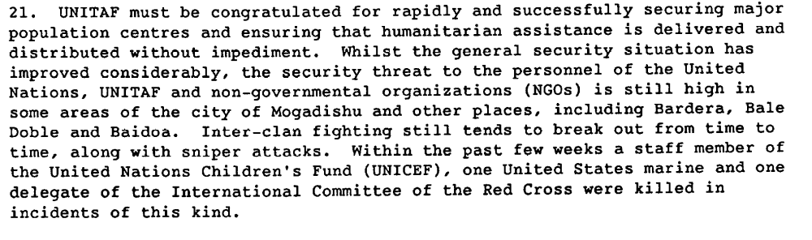

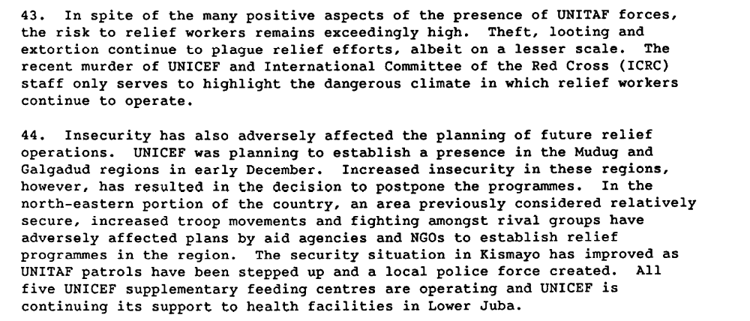

Report to the Secretary-General, 19 January 1993, S/25168

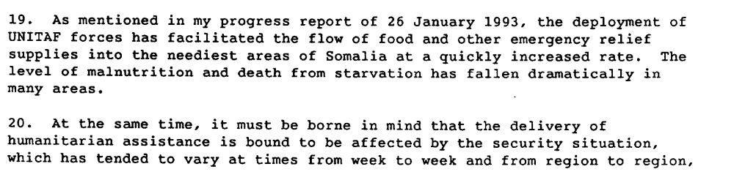
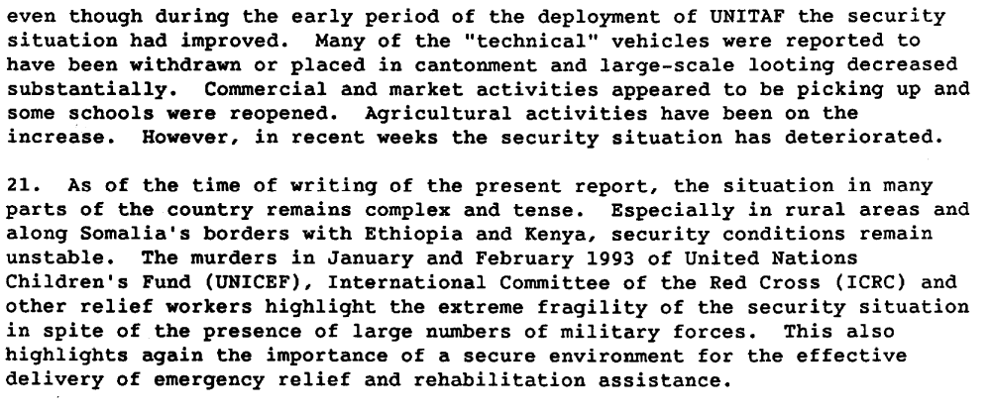
Report of the Secretary-General of 3 March 1993, S/25354

Assessment

Short-term compliance
No or marginal compliance (1) | Medium low compliance (2) | X Medium high compliance (3) | Full or almost full compliance (4)

Considerations underlying the assessment

Within the six months following the adoption of the resolution, the demand addressees took significant measure to necessary to facilitate the efforts of the United Nations, its specialized agencies and humanitarian organizations to provide urgent humanitarian assistance to the affected population in Somalia.

Medium-term compliance

Description of the addressee(s)’ conduct

“In June and July (1994), the security situation was marred by clashes among clans and sub-clans, especially in Mogadishu, and by a further increase in banditry. The recurring outbreaks of inter-clan fighting brought all humanitarian activities in Mogadishu and its immediate vicinity to a near-standstill for several weeks. There were further attacks against UNOSOM II personnel resulting in a number of fatal casualties.”
On 25 August, the Security Council expressed grave concern at the deteriorating security situation in Somalia and deplored attacks and harassment directed against UNOSOM II and other international personnel. The Council was also concerned by the lack of progress towards reconciliation among Somali factions. It attached great importance to accelerated inter-clan reconciliation, in particular among the Hawiye sub-clans, with the involvement of all concerned”

The then Under-Secretary-General for Peacekeeping Operations, Mr. Kofi Annan, visited Mogadishu in preparation for the report the Secretary-General submitted to the Security Council on 14 October. In that report, the Secretary-General said that the process of national reconciliation had not kept pace with achievements in the humanitarian area.”
The protracted political impasse, the Secretary-General continued, had created a vacuum of civil authority and of governmental structure in Somalia, leaving the United Nations with no function to build on. The presence of UNOSOM II troops had limited impact on the peace process and on security in the face of continuing inter-clan fighting and banditry.”

UNOSOM II
http://www.un.org/Depts/dpko/dpko/co_mission/unosom2backgr2.html

Assessment

Medium-term compliance
X No or marginal compliance (1) | Medium low compliance (2) | Medium high compliance (3) | Full or almost full compliance (4)

Considerations underlying the assessment

Within the two years following the adoption of the resolution, the demand addressees did not take all measures necessary to facilitate the efforts of the United Nations, its specialized agencies and humanitarian organizations to provide urgent humanitarian assistance to the affected population in Somalia.

Depth of demand

Assessment

Level of depth of demand
Low depth of demand (1) | X Medium depth of demand (2) | High depth of demand (3)

Considerations underlying the assessment

“ By mid-October, Cohen and other State Department officials expressed surprise that Somalis would destroy their cities and kill their own citizens in order to control food, which was the only viable economic activity left in the country. This was something that they had never experienced in previous African famine. Cohen believed that Somalia was the only case where there was “an inability to get aid through because food was used as a currency”.
Kenneth Rutherford. 2008. Humanitarianism Under Fire: The US and UN Intervention in Somalia. Kumarian Press, p.54.

Level of confidence about coding decisions

Level of confidence about coding decision
Extremely high | X High | Moderate

Comments to IPI (if any)

